Home page
The body text of most section is light white.. make it brighter and little bold or thick font
- Hero video- can you add Backdrops Exhibition in full in the prompt. d in backdrops not to be capital.
- Reduce size of Worldwide Projects down to two points. Increase the text size of the body proportionate to the heading.. make it more visible font
- ‘What clients say ’ increase size its not visible. Google Review reduce size
- Bring your visions to life - reduce size. stretch the steps from left to right more and increase font size. Its small to read.
- A picture gallery after video cases
- Installing exhibition booths- body thick bright font and size increase
- Create your vision- font increase. Not visible
- Inquire now tab make it brown/white same like other tabs
- One tab ‘connect with us’ to be put on beginning after WE build experiences and connect it to the contact form

- Add this paragraph after installing exhibition booths

Add the picture below

SUSTAINABILITY AS A STANDARD, NOT AN AFTERTHOUGHT
At BEX, sustainability is not a separate initiative, it is integrated into the way we design, manufacture, manage, and deliver projects. We believe that exceptional brand experiences should create lasting impact for audiences, not unnecessary impact on the environment.
What differentiates BEX is our commitment to responsible execution. Through intelligent material selection, reusable exhibition systems, modular construction techniques, efficient production planning, optimized logistics, and asset lifecycle management, we help clients reduce waste, maximize resource utilization, and improve long-term project value.
Our in-house infrastructure and manufacturing capabilities enable greater control over materials, production processes, and quality standards, allowing us to deliver sustainable solutions without compromising creativity, functionality, or visual impact. By extending the life of exhibition assets, minimizing material wastage, and adopting efficient operational practices, we support brands and agencies seeking more responsible ways to engage their audiences.
The result is a smarter approach to experiential delivery—one that balances innovation, performance, cost efficiency, and environmental responsibility. For BEX, sustainability is more than a commitment; it is a competitive advantage that helps our clients build for today while preparing for tomorrow.
You can put left side pic and right side text
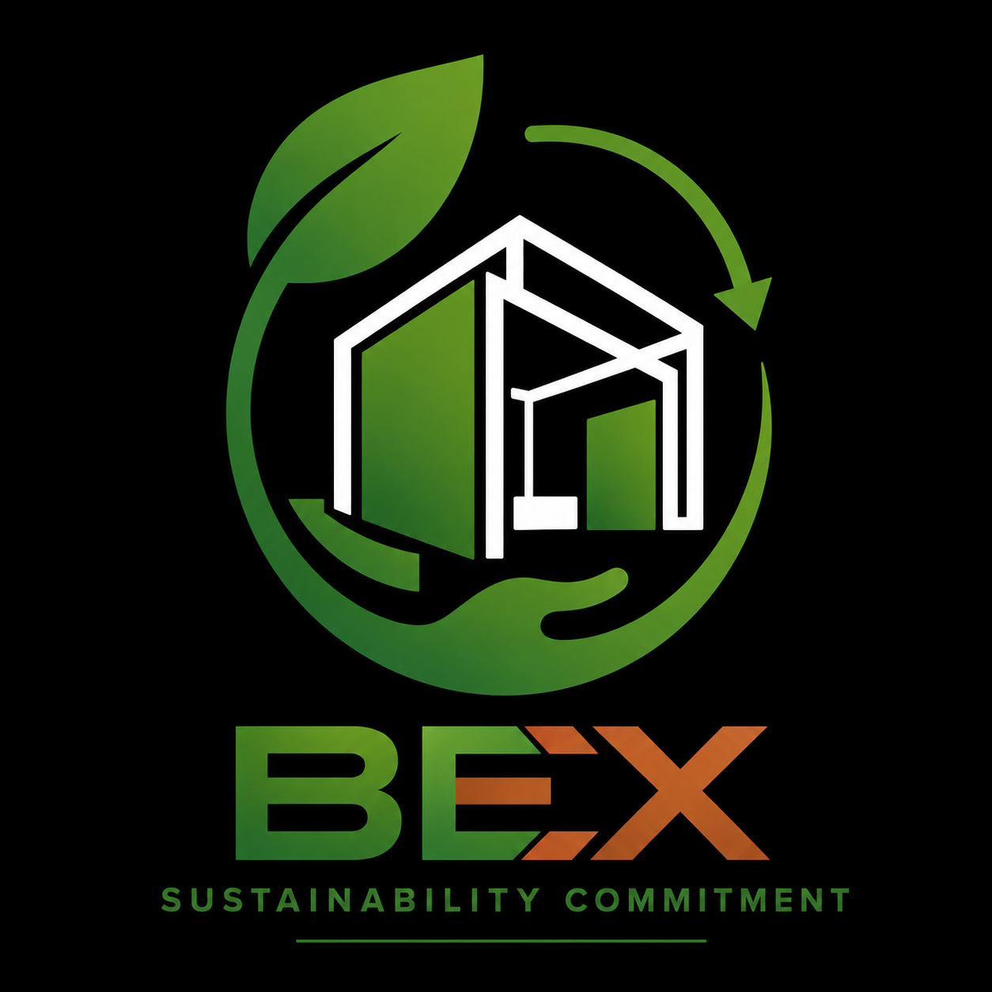

Footer
1-Address contact address contact—make it like this format
2- in uae address add number +971 50 7613437
About us
- Executive profile increase size. Not visible
Nebeel Aboobacker decrease size and make it lower case. No Full caps
- Why agencies choose us – make it lower case . No full caps
- Bex core values not able to read. The inside text very small ..speed to reduce..cursor not holding. Make it a pop out or give read more expanders

Contact us
